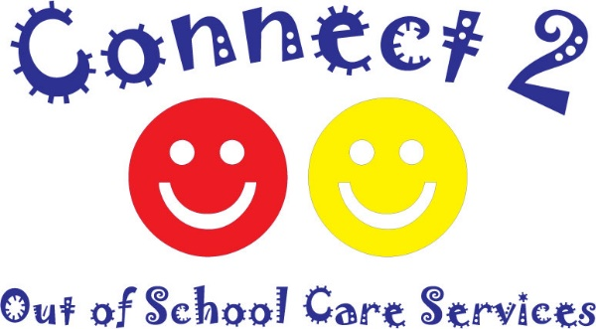
Covid-19 Policy
Statement
Covid-19 is a new illness that can affect your lungs and airways. It is caused by a virus called Coronavirus. Symptoms can be mild, moderate, severe or fatal. This policy and associated risk assessment are to limit the spread of the virus within the setting.
Who is at risk?
All patrons of the setting are at risk including: staff, children, parents /carers of the children attending, any other individuals involved in the day to day operation of the setting. Some groups of people are more vulnerable to the virus and these include the elderly, pregnant women and those with existing underlying health conditions.

What controls are required to limit the spread of the virus?
The following controls will be in place at all times:
- Handwashing
- All staff and children will be required to wash their hands immediately upon entry to the setting and before leaving.
- Hand washing facilities will be available at all times with soap and water in place.
- Paper towels will be used to dry hands and these will be placed in a lidded bin.
- The lidded bin will be emptied safely at least every hour.
- Gel sanitisers will be available in any areas where there are no immediate handwashing facilities for example in the outdoor areas.
- Staff and children will be reminded to wash their hands on a regular basis for a period of 20 seconds with soap and water and reminded of the importance of drying hands properly with the disposable towels. Children will be supervised at all times when hand washing to ensure that they do so properly.
- All children will be reminded to catch coughs and sneezes in a tissue which will be disposed of immediately in a lidded bin. The contents of the lidded bin will be disposed of at least every hour. Follow Catch it, Bin it, kill it to avoid touching the face, eyes, nose or mouth with unclean hands. Tissues are made available throughout the setting.
- Emollient creams will be available within the setting to protect hands from increased washing.

- Cleaning
Frequent cleaning and disinfecting of objects and surfaces that are touched regularly particularly in areas of high use such as door handles, light switches, furniture and toys. The areas will be cleaned regularly using appropriate cleaning products and methods. Rigorous checks will be carried out by managers to ensure that the procedures are being fully adhered to at all times.

- Social Distancing
The recommended distance for safe distancing is 2metres however this is difficult to maintain in a setting such as an out of school care. The following changes will be made to the running of each session:
- Parents /carers will not be permitted to enter the setting. Their child/children must be dropped off/picked up at the door.
- All bags to remain outside. Cover will be provided in case of rain.
- Parents will be asked to practice safe distancing of 2 metres whilst waiting to drop off/pick up their children. We appreciate that this will increase the time waiting to enter the out of school care therefore please stagger getting out of your car to avoid long queues.
- Group sizes will reflect the number of staff available to ensure that groups are kept as small as possible.
- Lunch times and snack times will be staggered to keep the group sizes small.
- Some activities may be suspended including group time, sand play, water play, play dough, cooking activities and any others which pose a high risk of contamination.
- All resources will be cleaned and disinfected immediately after use.
- Outdoor play will be encouraged as much as possible.

- Sickness
- If anyone becomes unwell with a continuous new cough or a high temperature, they will be isolated and sent home to follow the stay at home guidelines.
- Children and staff with any signs of illness should not attend out of school care.
This policy was adopted on 2nd May 2020 and will be reviewed on a weekly basis.

Signed on behalf of the Out of School Care Date

